1. Introduction to Artificial Intelligence

What is AI?

Artificial intelligence is the simulation of human intelligence processes by machines, especially computer systems. Specific applications of AI include [expert systems](https://www.techtarget.com/searchenterpriseai/definition/expert-system), natural language processing, speech recognition and [machine vision](https://www.techtarget.com/searchenterpriseai/definition/machine-vision-computer-vision).

AI perspectives: Acting and Thinking humanly, Acting and Thinking rationally

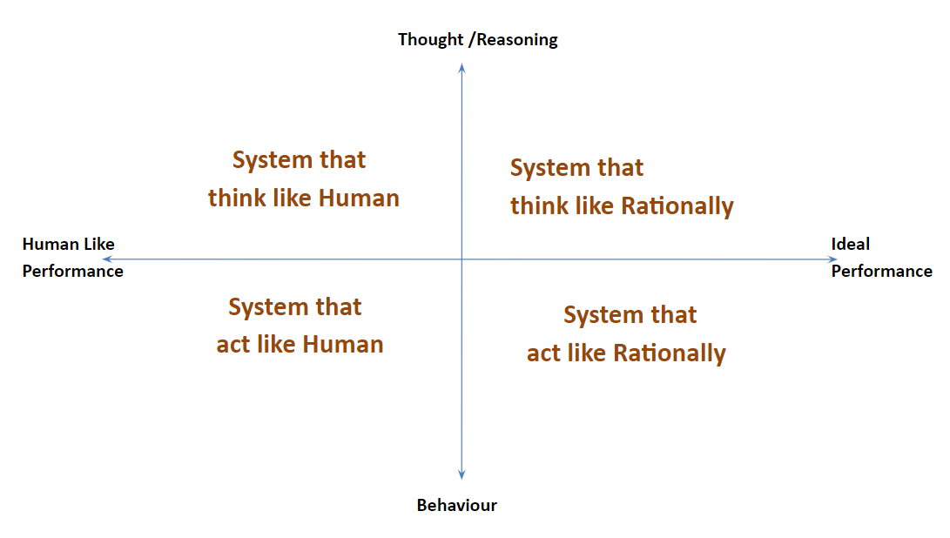

* Acting Humanly:

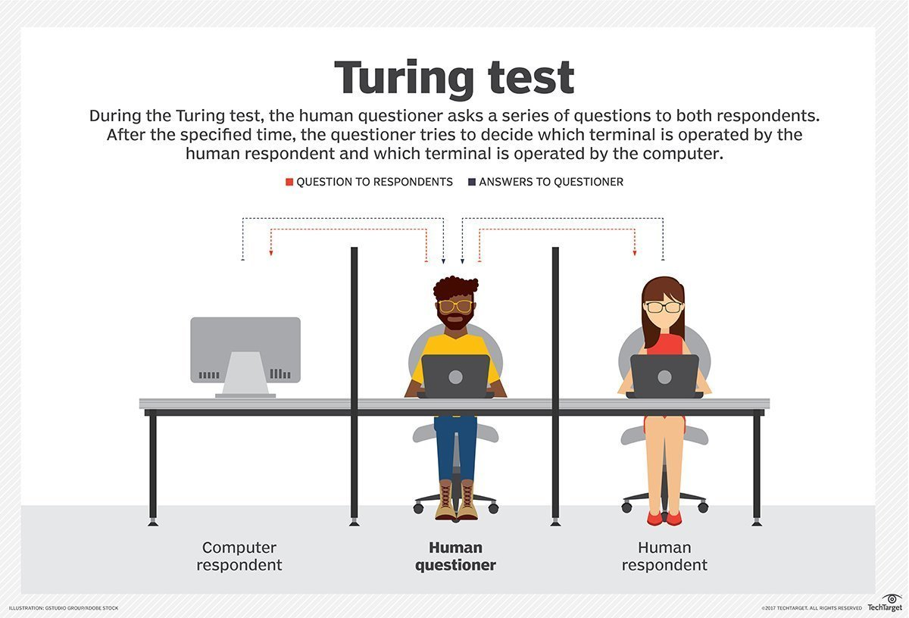The Turing Test approach – Acting like a human.

* Thinking Humanly:

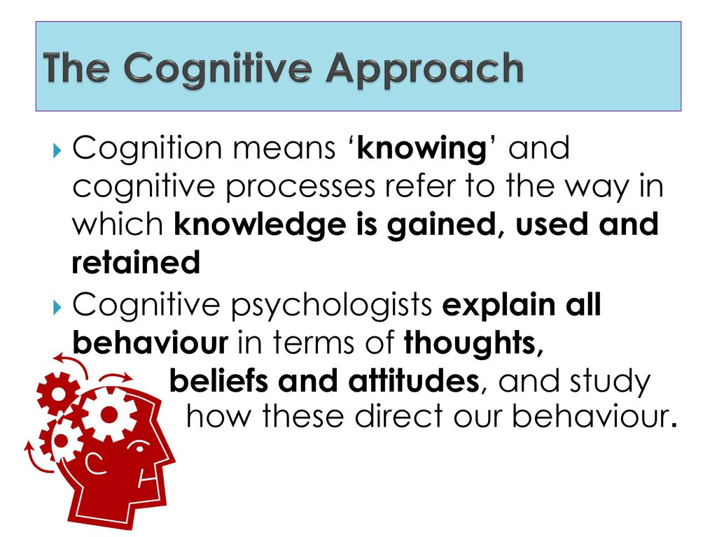The cognitive modelling approach – Thinking like a person.

* Thinking Rationally:

The laws of thought approach – Thinking rationally is a logical process and it concludes based on symbolic logic. The famous syllogisms, “Socrates is a man; all men are mortal; therefore, Socrates is mortal”.

* Acting Rationally:

The rational agent approach – Rational agent acts to achieve high value and brings the best possible outcome for any given task.

Applications of AI

* AI in Astronomy

Artificial Intelligence can be very useful to solve complex universe problems. AI technology can be helpful for understanding the universe such as how it works, origin, etc.

* AI in Healthcare

In the last, five to ten years, AI becoming more advantageous for the healthcare industry and going to have a significant impact on this industry.

Healthcare Industries are applying AI to make a better and faster diagnosis than humans. AI can help doctors with diagnoses and can inform when patients are worsening so that medical help can reach to the patient before hospitalization.

* AI in Gaming

AI can be used for gaming purpose. The AI machines can play strategic games like chess, where the machine needs to think of a large number of possible places.

* AI in Finance

AI and finance industries are the best matches for each other. The finance industry is implementing automation, chatbot, adaptive intelligence, algorithm trading, and machine learning into financial processes.

* AI in Data Security

The security of data is crucial for every company and cyber-attacks are growing very rapidly in the digital world. AI can be used to make your data more safe and secure. Some examples such as AEG bot, AI2 Platform, are used to determine software bug and cyber-attacks in a better way.

* AI in Social Media

Social Media sites such as Facebook, Twitter, and Snapchat contain billions of user profiles, which need to be stored and managed in a very efficient way. AI can organize and manage massive amounts of data. AI can analyse lots of data to identify the latest trends, hashtag, and requirement of different users.

* AI in Travel & Transport

AI is becoming highly demanding for travel industries. AI is capable of doing various travel related works such as from making travel arrangement to suggesting the hotels, flights, and best routes to the customers. Travel industries are using AI-powered chatbot which can make human-like interaction with customers for better and fast response.

* AI in Automotive Industry

Some Automotive industries are using AI to provide virtual assistant to their user for better performance. Such as Tesla has introduced TeslaBot, an intelligent virtual assistant.

Various Industries are currently working for developing self-driven cars which can make your journey more safe and secure.

* AI in Robotics:

Artificial Intelligence has a remarkable role in Robotics. Usually, general robots are programmed such that they can perform some repetitive task, but with the help of AI, we can create intelligent robots which can perform tasks with their own experiences without pre-programmed.

Humanoid Robots are best examples for AI in robotics, recently the intelligent Humanoid robot named as Erica and Sophia has been developed which can talk and behave like humans.

* AI in Entertainment

We are currently using some AI based applications in our daily life with some entertainment services such as Netflix or Amazon. With the help of ML/AI algorithms, these services show the recommendations for programs or shows.

* AI in Agriculture

Agriculture is an area which requires various resources, labour, money, and time for best result. Now a day's agriculture is becoming digital, and AI is emerging in this field. Agriculture is applying AI as agriculture robotics, solid and crop monitoring, predictive analysis. AI in agriculture can be very helpful for farmers.

* AI in E-commerce

AI is providing a competitive edge to the e-commerce industry, and it is becoming more demanding in the e-commerce business. AI is helping shoppers to discover associated products with recommended size, colour, or even brand.

* AI in education:

AI can automate grading so that the tutor can have more time to teach. AI chatbot can communicate with students as a teaching assistant.

AI in the future can be work as a personal virtual tutor for students, which will be accessible easily at any time and any place.

Ethical challenges of AI

Enterprises face several ethical challenges in their use of AI technology.

* Explainability:

When AI systems go awry, teams need to be able to trace through a complex chain of algorithmic systems and data processes to find out why. Organizations using AI should be able to explain the source data, resulting data, what their algorithms do and why they are doing that. "AI needs to have a strong degree of traceability to ensure that if harms arise, they can be traced back to the cause," said Adam Wisniewski, CTO and co-founder of AI Clearing.

* Responsibility:

Society is still sorting out responsibility when decisions made by AI systems have catastrophic consequences, including loss of capital, health or life. Responsibility for the consequences of AI-based decisions needs to be sorted out in a process that includes lawyers, regulators and citizens. One challenge is finding the appropriate balance in cases where an AI system may be safer than the human activity it is duplicating but still causes problems, such as weighing the merits of autonomous driving systems that cause fatalities but far fewer than people do.

* Fairness:

In data sets involving personally identifiable information, it is extremely important to ensure that there are no [biases in terms of race, gender or ethnicity](https://www.techtarget.com/searchenterpriseai/definition/machine-learning-bias-algorithm-bias-or-AI-bias).

* Misuse:

AI algorithms may be used for purposes other than those for which they were created. Wisniewski said these scenarios should be analysed at the design stage to minimize the risks and introduce safety measures to reduce the adverse effects in such cases.